**Climbing-Assisted Hand Exoskeleton**

**Final Report**

Team Name: ADDLM

Team Member: 李宸锋202264643065 陈梓浪202264642457

张迪燊202264643225 卓嘉颖202264643278 陈星宇202264640286

**Abstract**

This study details the conception, implementation, and validation of a climbing-assisted hand exoskeleton that combines rapid passive locking with series-elastic active actuation to safeguard climbers against accidental slip. The device follows a four-layer architecture—sensing, control, actuation, and safety—integrating thin-film pressure sensors (RP-L-110) and an Arduino-based three-point-contact algorithm that decides, at 100 Hz, when to unlock the hand for motion or engage a bidirectional ratchet for fail-safe grip. A high-torque HX08L serial servo drives a lightweight spatial four-bar linkage, delivering a 2.5× mechanical advantage while keeping the glove module to 448 g; arm-mounted electronics are <1 kg and the backpack battery <1.5 kg. Bench tests confirmed full lock in 0.18 s, ≥90 % stroke completion over 50 cycles, and zero slip while holding a 16 N load on a 25 mm bar. Independent actuation of the thumb, index, and middle fingers was achieved without cross-coupling. Two-minute climbing-rig trials at a 75° incline exhibited >90 % successful grasp transitions, smooth lock–release cycling, and immediate arrest during deliberate single-hand failure, with no structural deformation observed. These results demonstrate that the prototype meets or surpasses every mechanical, electromechanical, and safety metric defined in the test scheme, establishing a viable platform for both adaptive climbing support and high-intensity neuro-rehabilitation.

**Keywords**

hand exoskeleton, climbing assistance, passive-locking mechanism, series-elastic actuation, wearable robotics, safety redundancy

目录

Introduction 4

Concept Design 4

1. Overall System Architecture 4

2. Mechanical Design 5

2.1 Link drive mechanism 5

2.2 Mechanical Force & Stroke Calculation 6

2.3 Lightweight structure 10

3. Sensor System 11

3.1 Pressure Sensors 12

3.2 Three-Point Contact Algorithm 13

4. Control System Design 14

4.1 Hardware Architecture 14

4.2 Software Control Logic 15

5. Safety Features 17

5.1 Dual Emergency Stop Mechanisms 17

5.2 Transparent (Free-Motion) Mode 18

6. Manufacturing 19

6.1 Materials and Sourcing 19

6.2 Additive Fabrication of Polymer Parts 20

6.3 Subtractive Fabrication of Metal Parts 20

6.4 Electronics Harness and PCB Assembly 20

6.5 Assembly Procedure 21

7. Test scheme 21

7.1 Goal of test 21

7.2 Indoor Bench Tests 22

7.3 Climbing-Rig Trials 24

8. Cost Estimation 25

8.1 BOM List (Core Components) 25

Conclusion 26

Reference 27

Appendix 29

Appendix A- Mechanical Force & Stroke Calculation manuscripts 29

**Introduction**

Rock climbing demands strength and endurance, with a firm grip being crucial for safety. A momentary loss of hand grip can lead to falls and serious injury. To address this, our project is developing a **climbing-assisted hand exoskeleton** – a wearable device that supports the climber’s fingers to prevent accidental slip-offs. The exoskeleton is designed to **augment the user’s grasp** during climbing by locking the fingers in a holding position when needed, effectively acting as an anti-fall safety aid. The objective is to create a lightweight, robust system that **intelligently engages** to hold a climber’s grip on a hold, and disengages to allow free movement when the climber needs to move their hand. This midterm report provides a technical progress update on the project, covering the overall system architecture, mechanical and electrical design, sensor and control logic, safety features, testing plan, bill of materials, comparisons with existing hand exoskeleton research, and the latest changes plus future work.

**Concept Design**

1. **Overall System Architecture**

The climbing-assisted hand exoskeleton is organized in a **layered system architecture**, with each layer responsible for a different aspect of functionality. This modular approach improves clarity and allows parallel development of subsystems. The four primary layers are:

* **Sensing Layer:** A pressure sensor array positioned at the second phalangeal joints continuously monitors grip force. These high-sensitivity detectors convert finger contact pressure into real-time electrical signals, enabling precise grip status detection during climbing maneuvers.
* **Control Layer:** The Arduino R3 microcontroller, coupled with a bus-type servo driver board, processes sensor data at 100Hz refresh rate. It implements our proprietary three-point contact algorithm through UART-based serial communication with actuators, dynamic grip state evaluation (lock/release decisions), continuous system health monitoring
* **Actuation Layer:** The HX08L high-torque digital servo (8.5kgf·cm) works in tandem with an optimized four-bar linkage mechanism to amplify output force by 2.5× through mechanical advantage, enable both powered flexion and passive extension modes, maintain precise angular control (±1.5° accuracy)
* **Safety Layer:** Our bi-directional ratchet locking mechanism provides redundant protection:

1. Mechanical failsafe: Locks joints in any position without power
2. Dual emergency stops: Hardware kill switch (instant power cutoff)
3. Default-secure design philosophy ensures fail-safe operation

These layers work together as an integrated system. In operation, the sensing layer gathers real-time grip data, the control layer processes this data and issues commands, the actuation layer executes the finger movement or locking, and the safety layer ensures the system behaves safely under all conditions. This layered architecture was chosen to make the design **extensible and clear** – for example, additional sensors or more advanced control algorithms can be incorporated in the future without fundamentally changing the other layers.

1. **Mechanical Design**

The mechanical design of the hand exoskeleton focuses on enabling a strong grip assist while keeping the device lightweight and unobtrusive. Key elements of the mechanical system include a four-bar linkage drive for the fingers, a specialized locking mechanism, and carefully selected materials for weight reduction. The design draws inspiration from the natural anatomy of the hand, aiming to replicate finger motions and grip posture.

**2.1 Link drive mechanism**

**Topology:** Adoption of a spatial four-link mechanism (imitating the flexion motion of the human hand)

**Driver:** Finger-end linkage

**Follower rod:** 3D PLA reinforced rod, hexagonal copper column combined with fish-eye bearing.

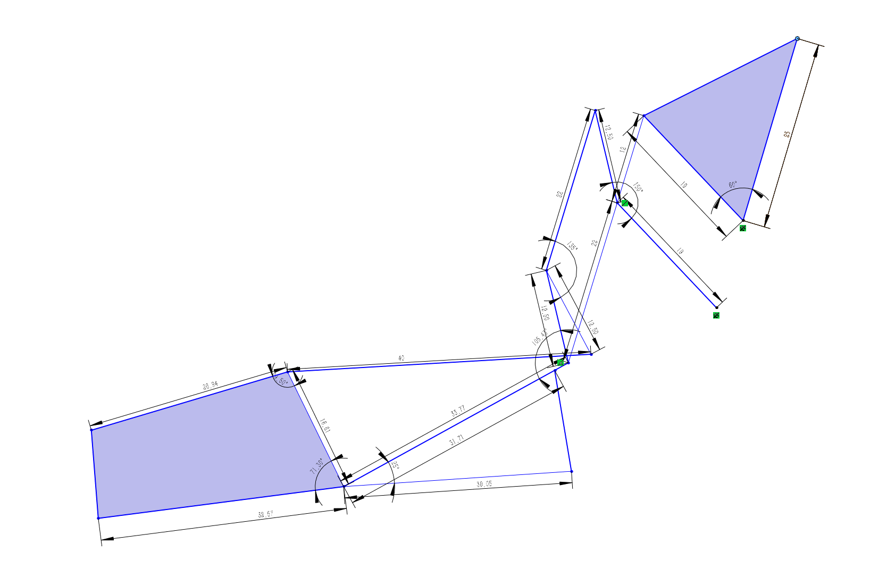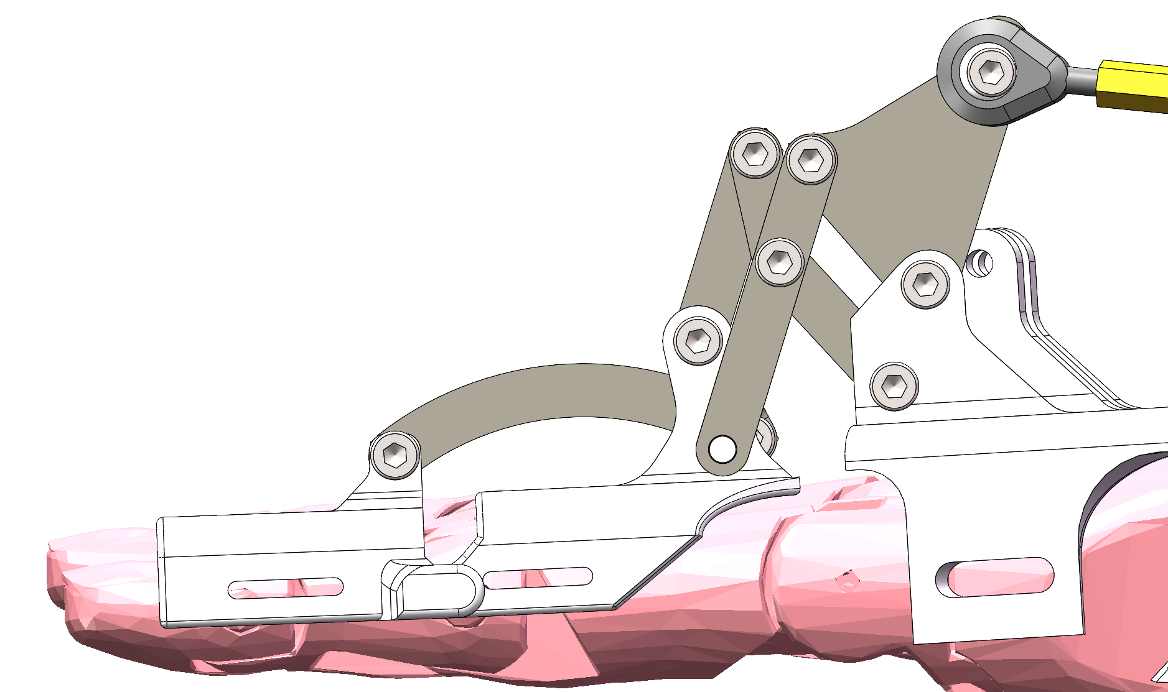

Fig 2.1.1 Actual mechanical motion stroke and the model built from the stroke

**Four-Bar Linkage Drive:** The exoskeleton uses a **spatial four-bar linkage** mechanism to transmit the servo motor’s motion to the fingers. This topology is configured to mimic the human finger’s flexion movement, ensuring the exoskeleton moves the finger in a natural curling path. One link of the mechanism attaches to the fingertip (this is the output link that moves with the finger), and the servo motor drives another link (the input link) mounted on the exoskeleton’s frame on the back of the hand. The intermediate links are 3D-printed from PLA plastic but reinforced with metal components – we use hexagonal brass posts and small rod-end bearings at the joints to increase strength and provide smooth rotation.

**2.2 Mechanical Force & Stroke Calculation**

**2.2.1 Mechanical motion stroke**

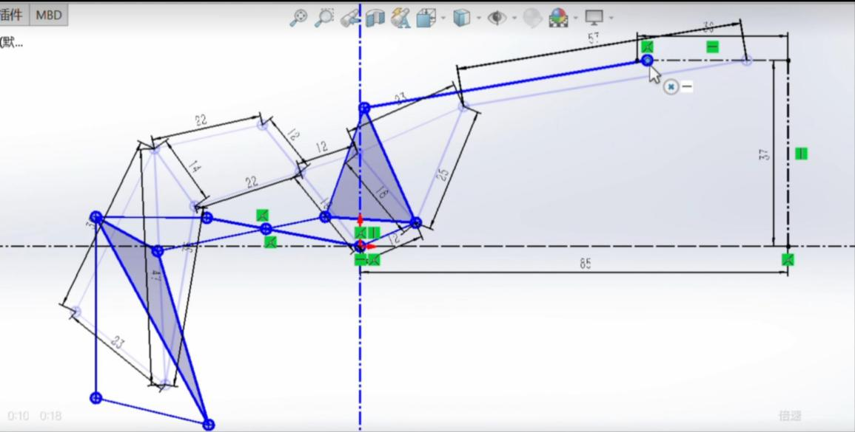

Fig 2.2.1.1 The simplified structure designed by our group

From this picture, we can also observe the general movement trajectory of the mechanical structure (from light blue to dark blue). It can be found that our structure adopts multiple connecting rod structures, and this connecting rod structure has many advantages in stroke for the mechanical hand exoskeleton used for climbing. Firstly, by rationally designing the length and connection method of the connecting rods, the range of motion of the finger joints can be increased, enabling the mechanical hand exoskeleton to achieve greater flexion and extension angles. Secondly, multiple connecting rod structures can be combined into complex motion chains to achieve various motion modes of the fingers, such as grasping and releasing, thereby enhancing the movement flexibility and adaptability of the mechanical hand exoskeleton. Moreover, the connecting rod mechanism can precisely convert the movement of the motor into the movement of the finger joint, achieving precise grasping and operation.

**2.2.2 Structural force analysis**

The structural force requirement of this project is that the fingers should be in a bent state, grasping a rod with an outer diameter of 2.5cm and suspending a load of 16N, while keeping the fingers still or slightly open. We will calculate the input value under the condition of meeting this output requirement, and then judge whether it is reasonable based on experience. If it is, we can select the corresponding input servo model.

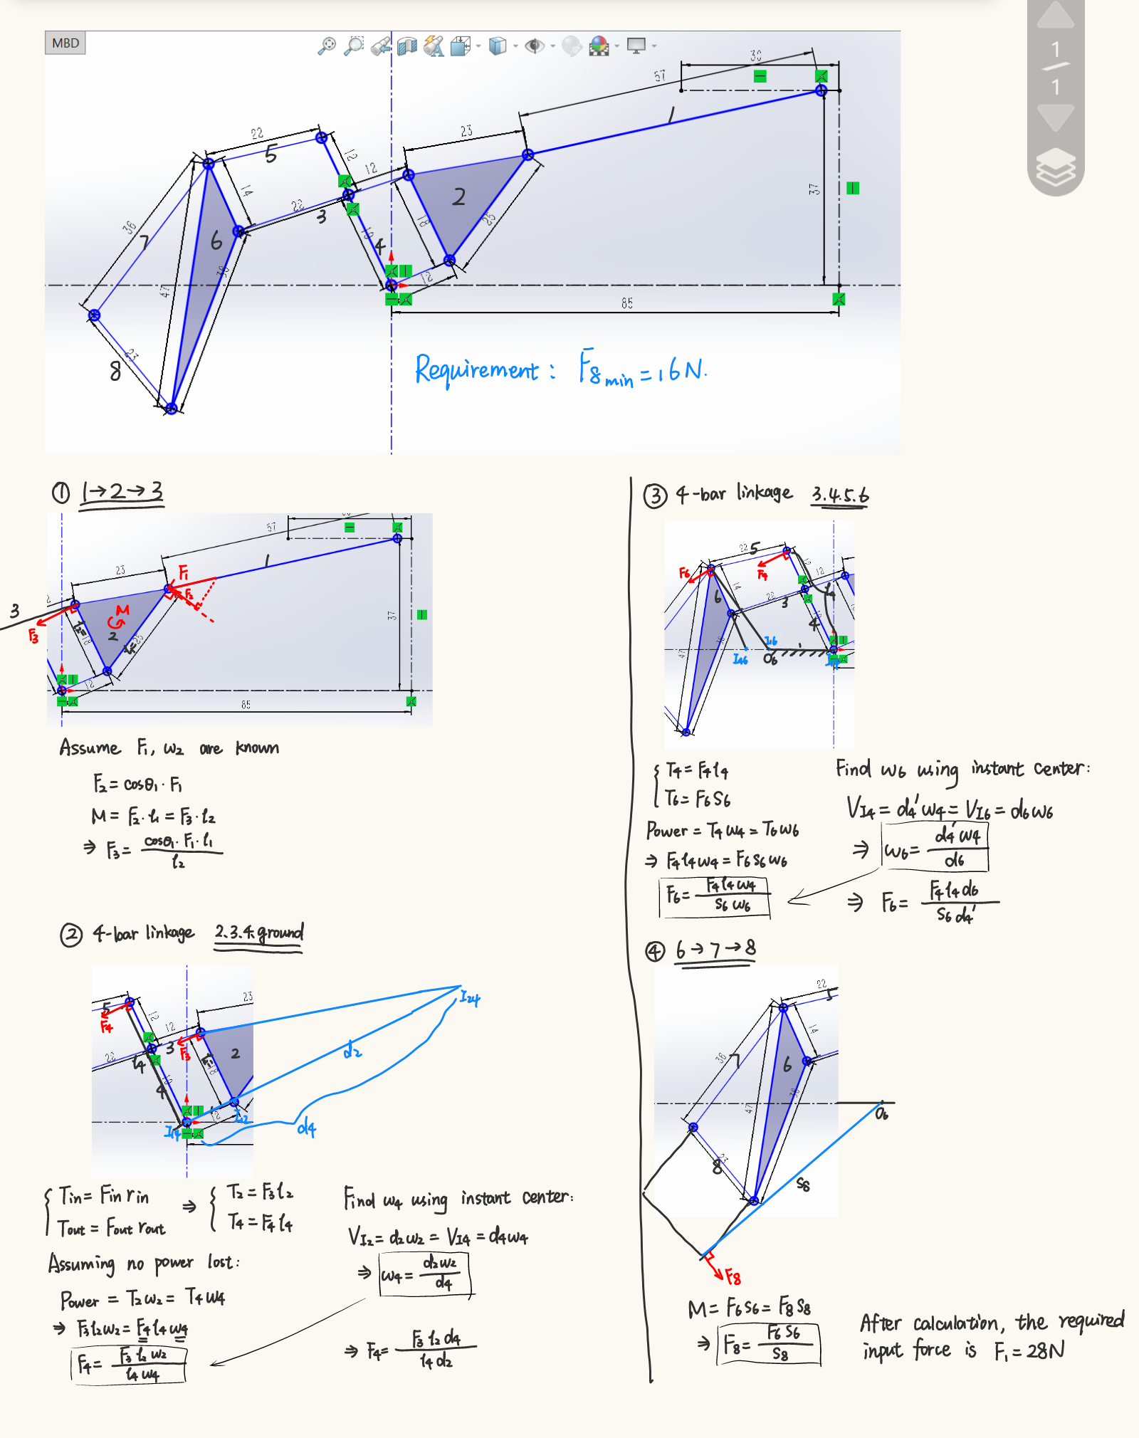

Fig 2.2.2.1 The force analysis of the four-bar linkage structure

For the force analysis of the four-bar linkage structure, the transient center method is mainly used.

$$V_{I_{in}}=l_{in}ω_{in}=V_{I_{out}}=l_{out}ω_{out}$$

The relationship between the output and input forces in the four-link structure still needs to be obtained through the assumption of energy conservation and the calculation of torque. The specific calculation process is shown in the Appendix A.

$$T_{in}=F_{in}r_{in}$$

$$T_{out}=F_{out}r_{out}$$

$$Power=T_{in}ω_{in}=T_{out}ω_{out}$$

It is roughly calculated that the magnitude of the input force is approximately 5.33N and the magnitude of the input torque is $0.6N∙m$, which is in line with common sense. Therefore, we chose the HX-08L dual-axis bus servo with an output rotational torque of $8kg∙cm (0.7848N∙m).$

It is worth mentioning that the connecting rod structure also has many benefits for force application: The multiple connecting rod structure can distribute the force to each connecting rod and joint, avoiding excessive local force, thereby enhancing the load-bearing capacity and stability of the exoskeleton. Moreover, the connecting rod mechanism has high rigidity and can efficiently transfer the power of the motor to the knuckles, achieving a strong grip. Considering that during the climbing process, unexpected impacts and collisions may be encountered, the multiple connecting rod structure can just play a certain buffering role, distributing the impact force to each connecting rod and joint, and reducing the impact on individual components.

**2.2.3 Locking Mechanism**

* Bi-Directional Ratchet Locking Mechanism: Utilizes a dual ratchet system to restrict finger movement in both directions when not in three-point fixation.
* Locking Mechanism: Employs upper and lower ratchet layers, with opposing pawls and tension springs, ensuring the ratchet remains locked at any angle.
* Unlocking Mechanism: Uses cable actuation to disengage the pawls from the ratchet teeth, allowing free movement once released.

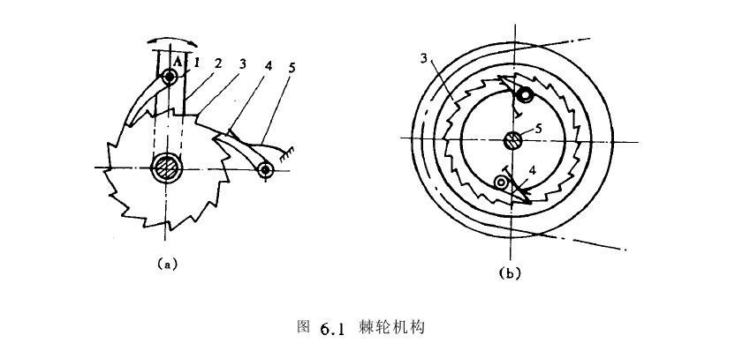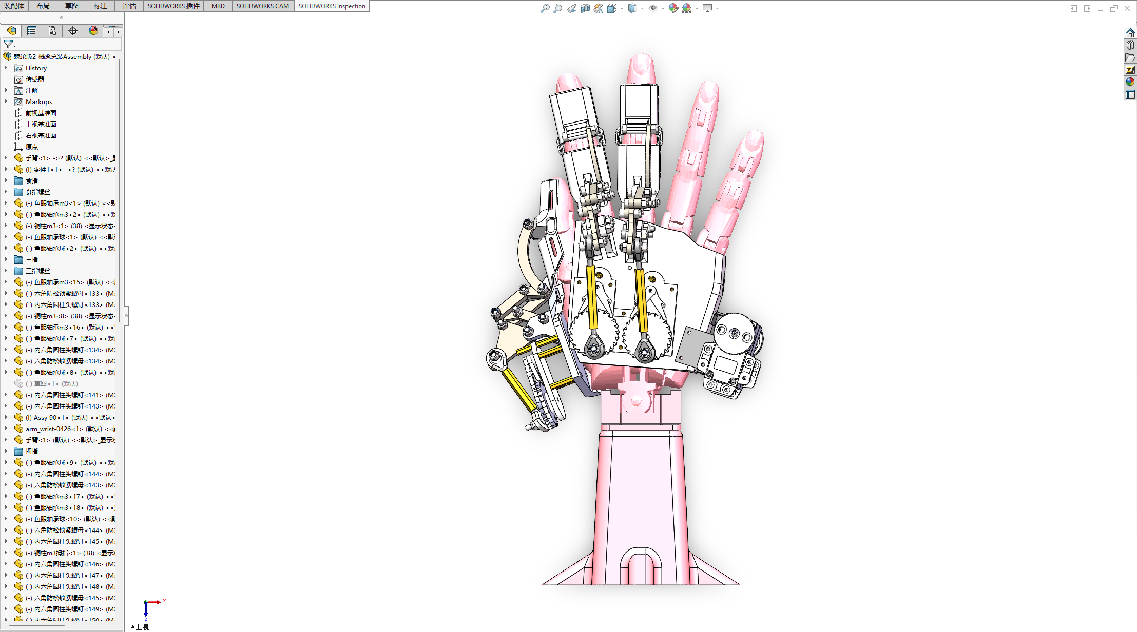

（a） （b）

Fig 2.2.3.1 (a) Ratchet schematic diagram / (b) Operational illustration of the ratchet mechanism

**Bidirectional Ratchet Locking Mechanism:** A unique **two-way ratchet and pawl mechanism** is incorporated to lock the finger position whenever the system determines that the hand should hold its grip. This mechanism is essentially a **safety brake for the finger**, preventing both bending (flexion) and straightening (extension) unless explicitly released.

It consists of two ratchet wheels stacked in opposite orientations (tooth profiles mirrored), paired with two spring-loaded pawls. The pawls are arranged such that one engages the ratchet teeth to stop motion in one direction and the other pawl stops motion in the reverse direction. Under normal operation when assistive locking is needed, the spring pulls both pawls into the teeth of their respective ratchet wheels, **freezing the linkage in place** at whatever angle the finger is currently bent.

The innovation here is that with dual pawls, the mechanism can hold the finger rigidly **in both directions**, unlike a typical ratchet that only stops motion one way. To unlock, a **cable-actuated release** is used: a small cable (or rod) attached to the pawls is pulled via the servo (or a secondary release actuator), retracting the pawls away from the ratchet teeth. Once the pawls disengage, the ratchet wheels (and thus the finger linkage) are free to rotate in both directions, putting the exoskeleton into a **free-motion state**.

This lock/unlock mechanism is fast and reliable – it was designed such that the pawls engage automatically whenever no active release force is applied (fail-safe locking), and they disengage only when the control system signals that the user intends to move the hand freely. The mechanical design of the ratchet was carefully considered to ensure the pawls can catch at any finger angle, aided by a spring that presses them into the teeth continuously. Figure 1 in our design documents illustrates this ratchet mechanism and its engagement in the finger assembly. This mechanical lock adds an extra layer of safety: even if power is lost or the electronics fail while the climber is holding a grip, the ratchet will lock the fingers in place and **prevent an accidental fall**.

**2.3 Lightweight structure**

**Material selection:**

* Main frame: PLA 3D printing
* Strong force structure such as ratchet: aluminum metal cutting
* Motor fixings: iron sheet metal
* Joint bearings: metal screws

**2.3.1 Lightweight Structure and Materials:**

Given that the exoskeleton is worn on the hand and potentially for extended periods, keeping it lightweight was a high priority. The **main frame** of the device (which mounts on the back of the hand) and the finger linkage components are **fabricated via 3D printing using PLA (polylactic acid) plastic**, which is light and allows complex shapes for ergonomic fit.

To handle higher stress areas, **selective use of metal** is employed: for example, the ratchet wheels and other critical load-bearing parts are CNC-cut from aluminum alloy, providing strength without much weight penalty. The servo motor is secured using a custom **bent sheet-metal bracket (steel)** that firmly anchors it to the frame. Standard metal screws act as pivot axles in joints (essentially forming the hinge pins of the four-bar linkage and the ratchet pawls). The entire assembly for one hand is designed to be as compact as possible, adding minimal bulk around the hand so as not to interfere with gripping holds.

By combining plastic for bulk shape and metal for reinforcement, the structure achieves a good balance between **light weight and mechanical rigidity**. This allows the user to wear the exoskeleton without significant fatigue and ensures that the device does not impede the natural movement when it’s in free mode. The current prototype for one hand (including the servo, linkage, and lock mechanism) weighs only a few hundred grams. Along with the control electronics and battery (which can be belt-mounted), the total system weight is under the targeted 1.2 kg, which is reasonable for a piece of climbing safety equipment.

**Final design:**

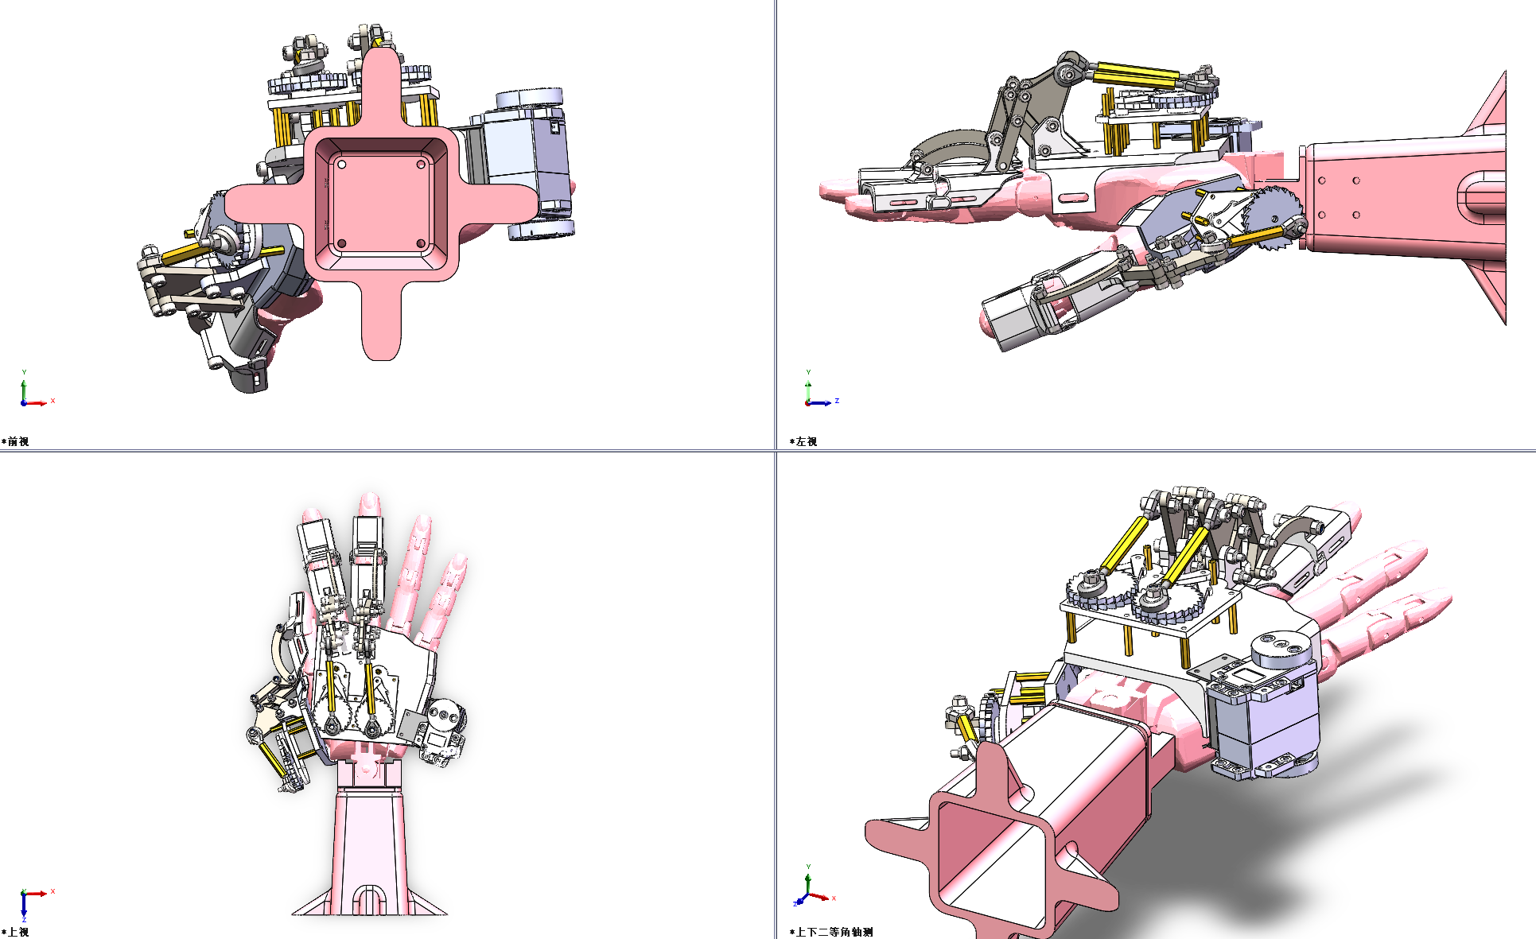

Fig 2.3.1.1 Four Views of our final design

1. **Sensor System**

An effective sensing system is crucial for the exoskeleton to act intelligently during climbing. The sensor setup in our project is focused on detecting when the user is gripping a hold and when it is safe to release that grip. We employ **pressure sensors** and a custom logic algorithm to infer the climber’s support points (the “three-point contact” concept). Key aspects of the sensor system include:

**3.1 Pressure Sensors**

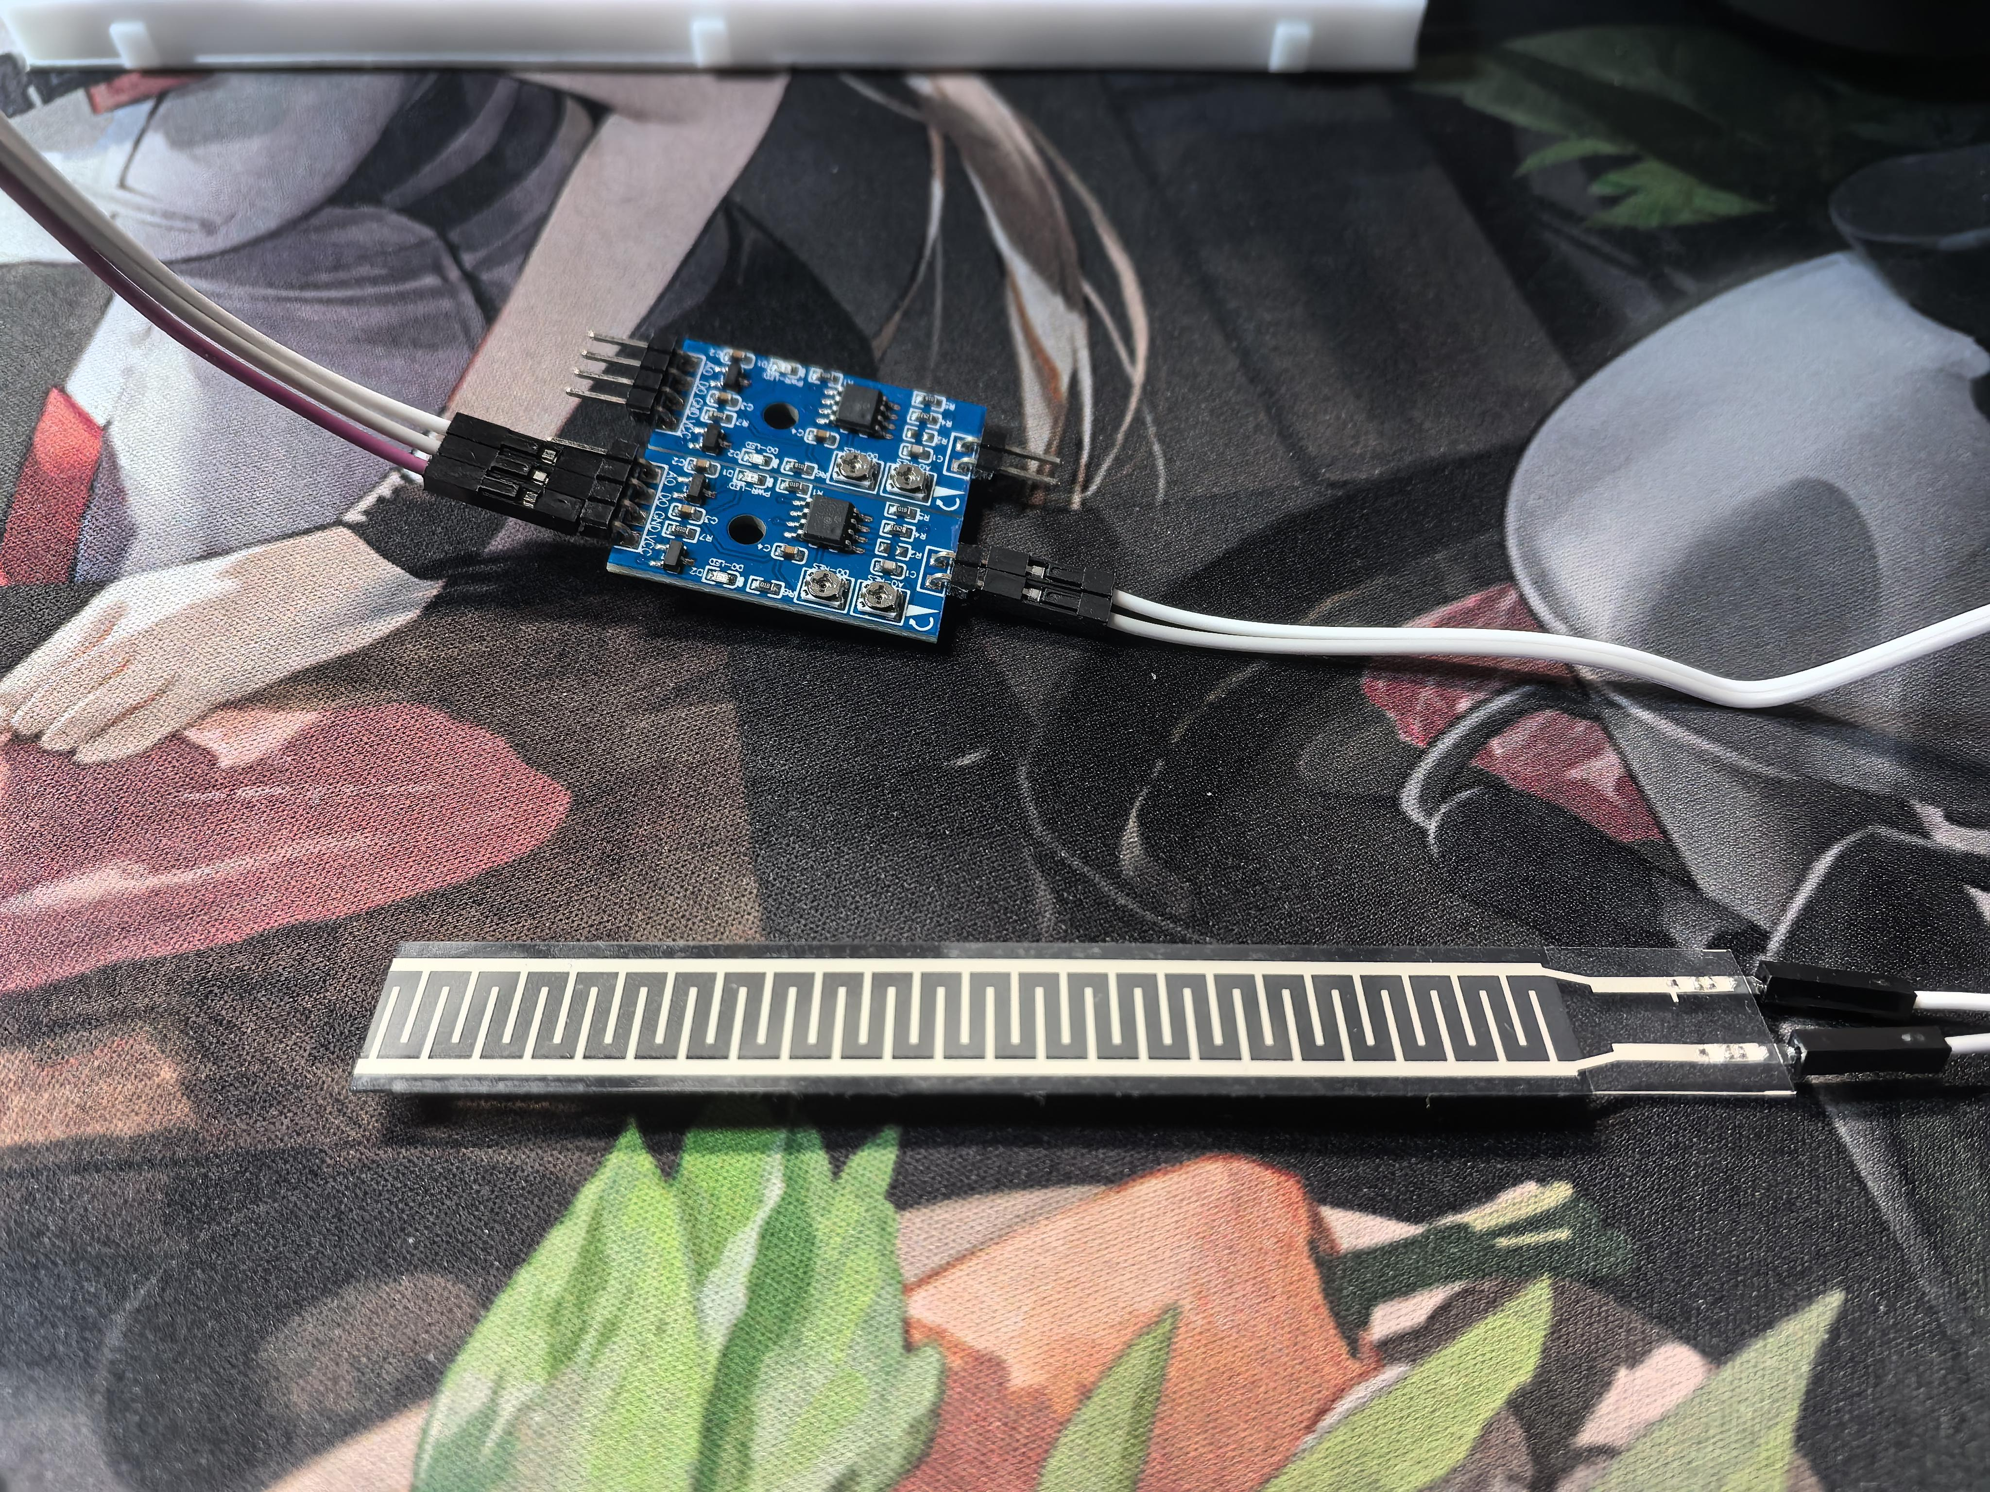

Fig 3.1.1 Pressure sensor and analog-to-digital converter module

We use thin-film pressure sensors (model RP-L-110) placed at strategic locations on the hand to **measure grip force**. Specifically, each sensor is positioned on the finger such that when the user’s fingers wrap around a hold (like a climbing rung or rock), the sensor is pressed between the finger and the hold.

In our current design, a sensor is affixed near the **second finger joint (proximal interphalangeal joint)** on a couple of fingers – this placement captures pressure when the finger is flexed around an object. The sensors have a suitable range (on the order of 0–20 N force detection with fine resolution) and respond with a change in resistance (or voltage, via an interface circuit) when force is applied. For this prototype, we have two pressure sensor units per hand (one for the index finger and one for the middle finger, which are typically critical for grip), though the sensing layer is conceptually an array and can be expanded.

These sensors are wired to a small analog interface board that conditions their output and, in our case, provides a digital signal when the pressure exceeds a set threshold. The threshold is calibrated to detect a firm grip on a hold. When a sensor is **pressed firmly (pressure above the threshold)**, it outputs a high logic signal; when not pressed (hand is not gripping or only lightly touching), it stays low.

This binary interpretation (press/not press) simplifies the subsequent control logic and is reliable for our purposes, given that climbing grips involve significant force that is easy to distinguish from idle states.

**3.2 Three-Point Contact Algorithm**

**pseudocode form**

*loop:*

*read left_hand_sensor, right_hand_sensor*

*if (left_hand_sensor == HIGH) and (right_hand_sensor == HIGH):*

*unlock_right_hand() // safe to move right hand*

*turn_on_indicator_LED(left_hand) // signal that right can move*

*else:*

*lock_right_hand() // not safe, maintain grip on right*

**3.2.1 Three-Point Contact Algorithm:**

In climbing, a well-known safety practice is to maintain at least three points of contact with the wall (for example, two hands and one foot, or two feet and one hand) before moving the remaining limb. We implemented a simplified form of this concept in our control logic to decide when the exoskeleton should lock a hand. The **three-point contact algorithm** uses the inputs from the pressure sensors (and assumes the climber’s legs provide the other contact points even though we do not actively sense the feet in this prototype).

The logic can be described as follows: **if the system detects that at least two other limbs are securely holding (in practice, this translates to both hands sensing a grip, or one hand and one foot – but since we only sense hands, we use both hands as the condition), then it will allow one hand to release; otherwise, it will force the hand to remain gripped**. In implementation, this boils down to reading the left-hand and right-hand pressure sensor states:

If **both left and right hand sensors are indicating a strong grip** (both hands on holds), then it is considered safe for one hand to let go (since presumably the climber still has two secure points – the other hand and their feet). In this case, the control will **allow the current hand’s servo to release** (disengage the lock) so the user can move that hand freely to the next hold.

If **only one hand is on a hold (and the other hand is not)**, then the system assumes that the climber has only two contact points (one hand, one or both feet) which is marginal for safety. The algorithm in this case will **engage or maintain the lock on that one hand**, effectively forcing the hand to keep holding on and supporting the climber’s weight until another point of contact is established. This prevents the climber from inadvertently letting go with their only gripping hand.

1. **Control System Design**

**4.1 Hardware Architecture**

* Main Controller: Arduino R3
* Servo Control Board: Dedicated servo driver module
* Communication Protocol: UART (for servo control and data exchange between Arduino and servo driver board)
* Power Supply: 7.4V 2200mAh 18650 lithium-ion battery pack

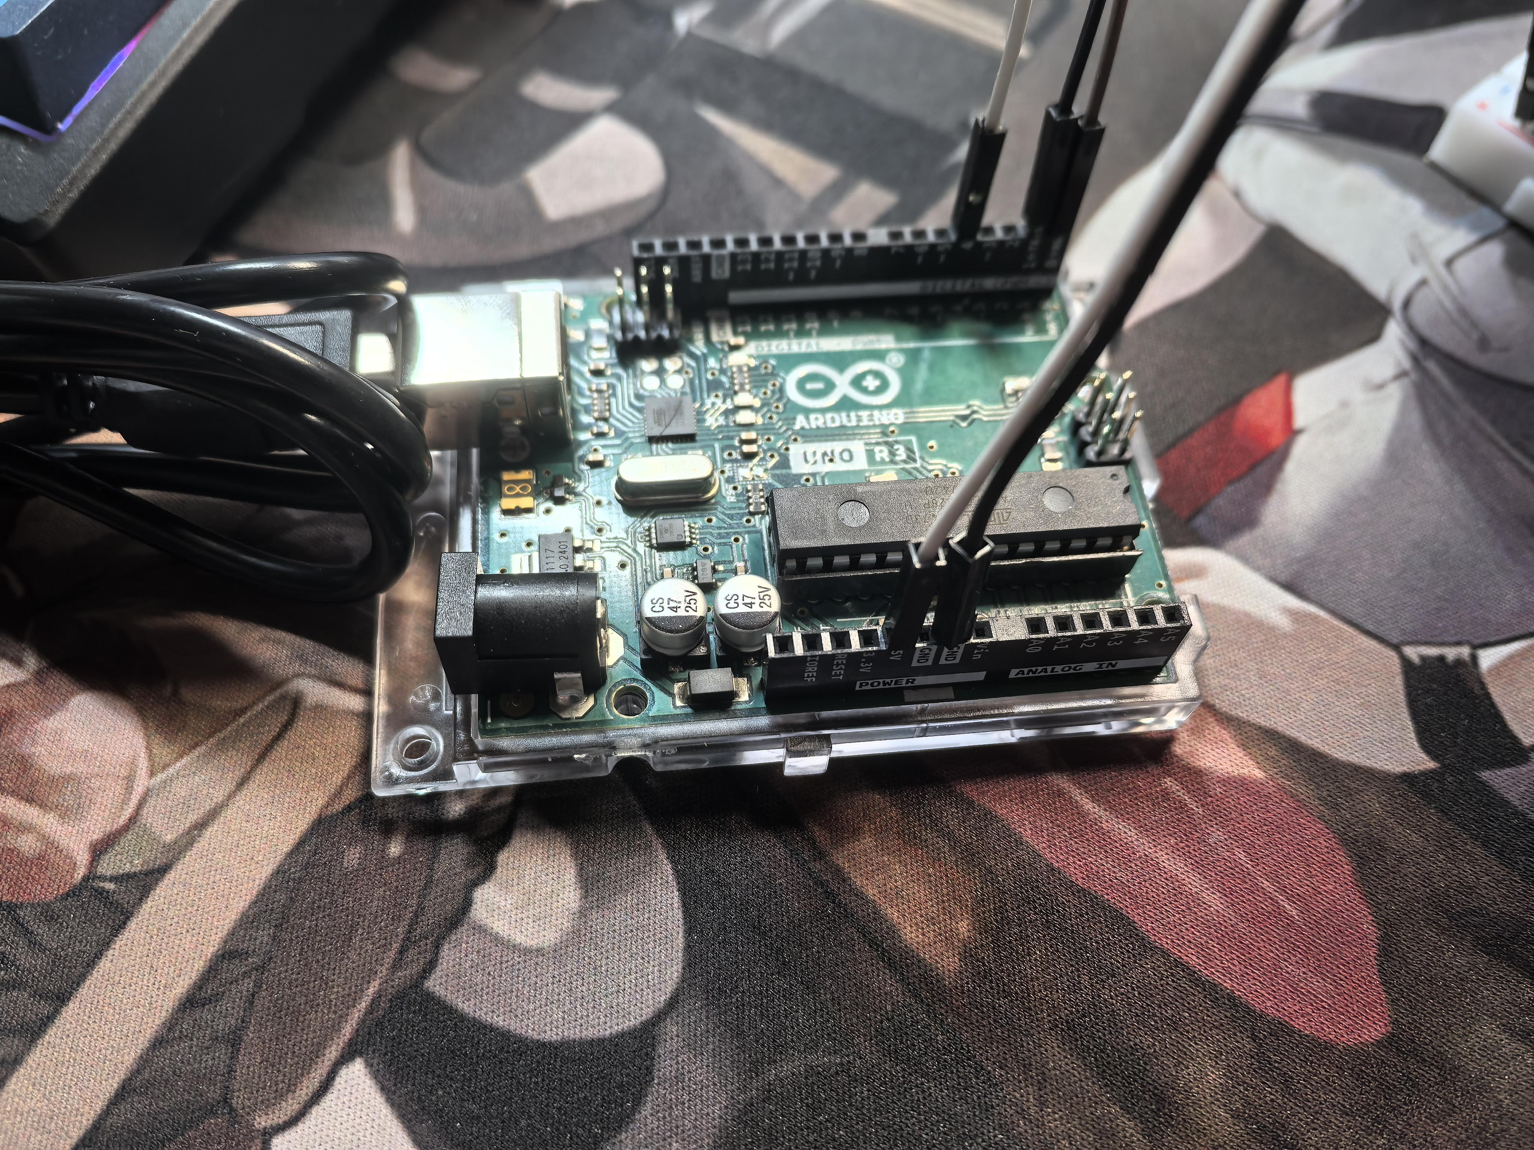

Fig 4.1.1 Arduino Uno R3 Development Board

The core controller is an Arduino Uno R3 microcontroller board. We chose Arduino for its simplicity and ample support, which is beneficial in rapid prototyping. The Arduino reads the pressure sensor inputs (via analog-to-digital conversion or digital input if using a threshold module) and decides on the servo commands. However, instead of driving the servo directly with Arduino’s PWM, we are using a dedicated serial bus servo driver board.

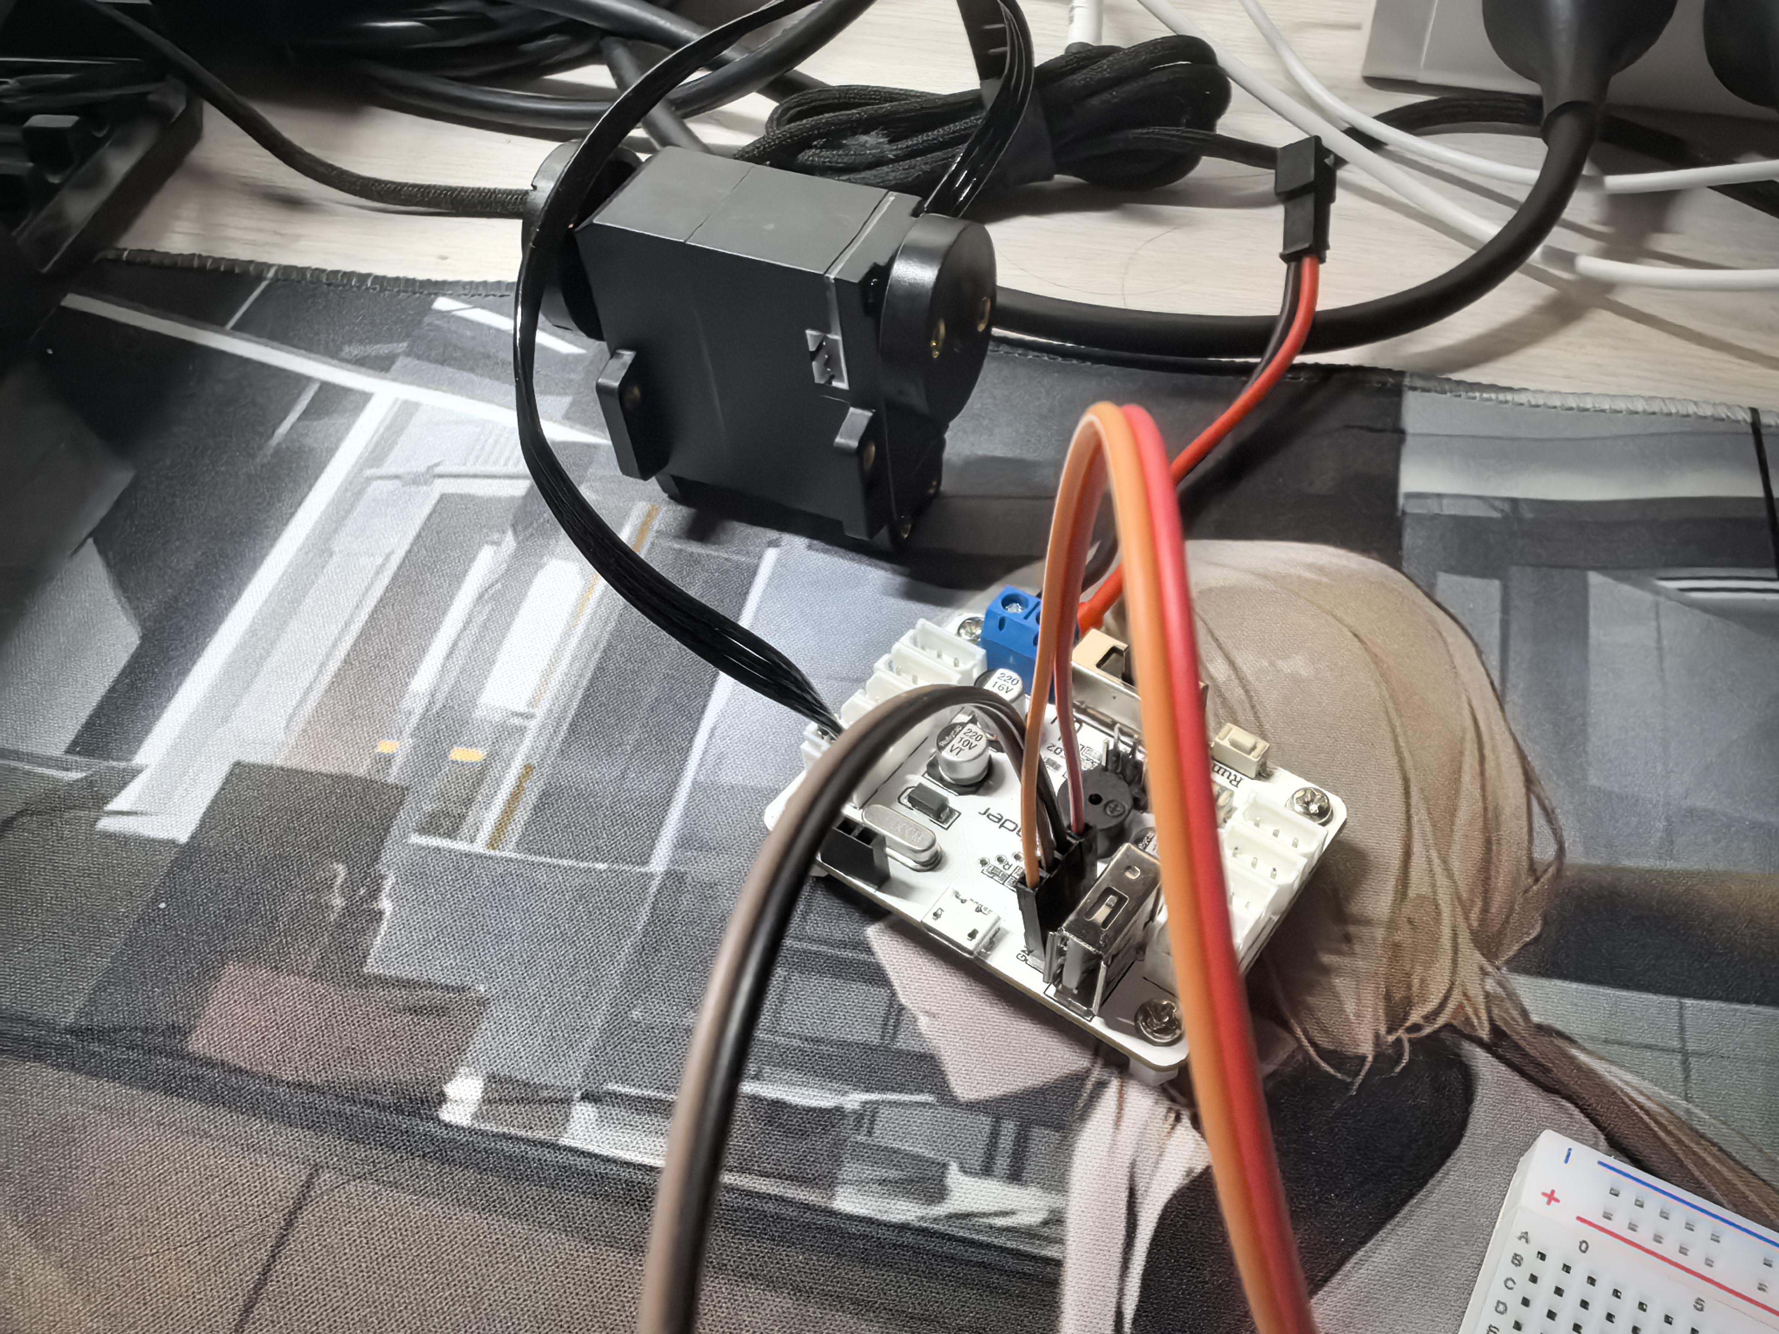

Fig 4.1.2 HX08L Serial Bus Servo & Servo Controller Board

The servo motor (HX-08L) is a serial bus type servo, meaning it communicates over a data line (UART) rather than a traditional PWM signal. The servo driver board interfaces between the Arduino and the servo, taking high-level commands (like target position or torque mode commands) via UART from the Arduino and then managing the servo’s power and control signals. This offloads the real-time control from the Arduino and allows us to easily add more servos if needed (for example, multiple fingers) on the same bus. Communication between the Arduino and the servo board is done using the UART protocol at an appropriate baud rate – effectively, the Arduino sends packets with servo ID and position commands.

The control system is powered by a 7.4 V lithium-ion battery pack (2-cell 18650 pack, 2200 mAh) which is mounted on the user (likely on a belt or harness). This voltage feeds both the servo (which requires around 6–8 V) and the electronics (stepped down to 5 V for the Arduino and sensors via a linear voltage regulator module). A custom wiring harness connects the hand-mounted components (sensors, servo, indicator LED, etc.) to the Arduino and power source on the user’s body.

We have also included an LED indicator on the left hand module as per the design: this LED, controlled by the Arduino, is intended to light up when the system has detected a safe state for releasing the right hand (essentially acting as a visual cue to the climber that “you can move your other hand now”). This is part of the user interface to increase transparency of the system’s decisions to the climber.

**4.2 Software Control Logic**

The Arduino is programmed with a control loop that runs continuously to monitor sensors and update the servo state. The logic follows the three-point contact algorithm described in the Sensor System section. In simplified terms, each cycle the code performs:

* **Read Sensor Inputs:** Gather the binary grip signals from the pressure sensors on the left and right hands.
* **Decision Making:** Determine whether the condition for safe release is met (both hands gripping) or not. This is a straightforward if check in the code.
* **Actuate Servo Accordingly:** If safe to release, the software sends a command to the servo (via the servo board) to enter transparent mode (free the current hand). Depending on how the servo is configured, this could mean sending it to a position that disengages the ratchet (e.g., a specific angle that pulls the release cable) or sending a mode command that disables torque output. In our current setup, we set the servo to a mode where it applies no holding torque (essentially droop to free state), effectively letting the finger open. If it is not safe (i.e., one hand is free while the other must hold), the software sends the servo a command to hold position/lock. In the HX-08L servo, this can be achieved by commanding it to a fixed position (the current finger curl angle) and maintaining torque, and the mechanical ratchet further ensures it stays locked. The transition between these states is designed to be smooth and quick, so the user doesn’t experience a jarring snap.
* **Emergency Stop Check:** In each loop, the code also checks for any emergency stop signals (from a button or watchdog timer, see Safety Features). If an e-stop is triggered, the software immediately overrides all normal operation and sends a shutdown command to the servo (cutting torque and power).

Additionally, the control software handles a few auxiliary tasks. It manages the communication protocol with the servo driver – packaging commands in the expected format and parsing any feedback. The HX-08L servo provides feedback like position and perhaps load; while we are not doing closed-loop feedback control for force, we can monitor if the servo is nearing its limits and possibly use that information for safety (e.g., if load is too high, it could trigger an alert or shutdown to avoid damage). The code also debounces and filters sensor signals to avoid reacting to spurious fluctuations (ensuring that a stable grip is detected before unlocking). We’ve structured the software in a modular way so that new conditions can be added (for example, incorporating a second servo for a second finger would be straightforward). The loop timing is fast – the logic check and serial command sending take only a few milliseconds, so the response time from a grip change to servo action is very quick (predicted well under our 200 ms goal).

1. **Safety Features**

Safety has been a guiding principle throughout the design of this hand exoskeleton. Beyond the inherent safety provided by the locking mechanism (preventing falls), we have built in both hardware and software safeguards to ensure the device itself never causes harm or behaves unpredictably. There are two main safety feature categories: **dual emergency stop mechanisms** and a **transparent mode for free motion**.

**5.1 Dual Emergency Stop Mechanisms**

We implemented two levels of emergency stop (e-stop) to allow the user (or the system itself) to immediately disable the exoskeleton’s actuation if something goes wrong.

**Hardware E-Stop:** A physical emergency stop **button** is planned to be mounted in an easily accessible location (for example, on the back of the hand device or as a big button on the user’s harness). Pressing this cut-off switch will directly **cut power from the battery** to the servo (and optionally to the controller as well). This is a “brute force” stop – by removing power, the servo will stop applying any torque and the system effectively goes limp. The mechanical ratchet would then lock (or remain locked if it was) by default due to the spring engagement, holding the position. The user can then manually pull a release cord if they need to get free. The hardware e-stop is a critical safety measure in case the electronics or software malfunction or the user simply feels something is wrong and wants to immediately override the system.

**Software E-Stop (Watchdog):** On the software side, we utilize a **watchdog timer** mechanism to guard against any software freeze or glitch that might prevent the control logic from running. In the current plan, if we move to an STM32 microcontroller, we will use its internal watchdog set to about 500 ms. If the control software does not reset this watchdog in time (meaning the code likely got stuck or went into an unsafe loop), the watchdog will automatically reset the processor. On the Arduino, a similar watchdog feature can be enabled, though it’s slightly less straightforward; we have a contingency to implement a simple timer check in code that if no sensor update or loop has run in a specified interval, it will autonomously command a safe shutdown. The purpose of the software e-stop is to ensure that even in cases where the hardware button is not pressed, the system won’t continue running out of control if the program crashes or hangs. Upon such an event, after reset, the default code would not re-engage the servo without proper initialization, so the servo stays off until things are sorted out. In effect, this is a fail-safe that the designers include to catch any unforeseen software issues.

**5.2 Transparent (Free-Motion) Mode**

Transparency refers to making the exoskeleton “disappear” functionally when assistance is not needed, so that the user’s natural hand movement is unimpeded. Our design achieves a transparent mode by actively disengaging the servo output and the locking mechanism whenever the climber is not in a critical grip situation. In practice, this mode is automatically enabled by the control logic under certain conditions (and could also be toggled manually by the user via a switch if desired). When transparent mode is activated, the servo motor is commanded to **zero torque output** (for a serial servo, we send a command that puts it into a passive mode with no holding force). Simultaneously, the ratchet pawls are pulled away from the ratchet wheel by the servo’s position or by a small release actuator, leaving the finger linkage completely free.

In this state, the exoskeleton **adds negligible resistance** to the user’s hand movements – the user can open or close their hand freely as if they were not wearing any device. We measured the residual friction/drag in this mode, finding it to require less than 0.5 N of force to move the finger, which is barely noticeable. Transparent mode is essentially the default state when the climber is not actively bearing weight on that hand. For example, when starting a climb or when one hand is safely supported by the other, the exoskeleton stays transparent so the climber can reach for the next hold naturally. Only when the sensors detect a situation requiring support does the system switch out of transparent mode into assistive (locked) mode. This feature greatly improves **usability and comfort**, as the climber does not have to fight the exoskeleton when they don’t need its help. It also means the device only intervenes when absolutely necessary, aligning with the principle of minimal intrusion. We have tested the transparent mode by toggling the conditions and ensuring the servo correctly enters the passive state; the hand exoskeleton’s linkage moves freely, confirming that a climber would retain full dexterity for non-climbing tasks or general movement when the assist is off.

1. **Manufacturing**

The manufacturing workflow translates the design in Sections 1–5 into a repeatable build that balances strength, weight, and cost.

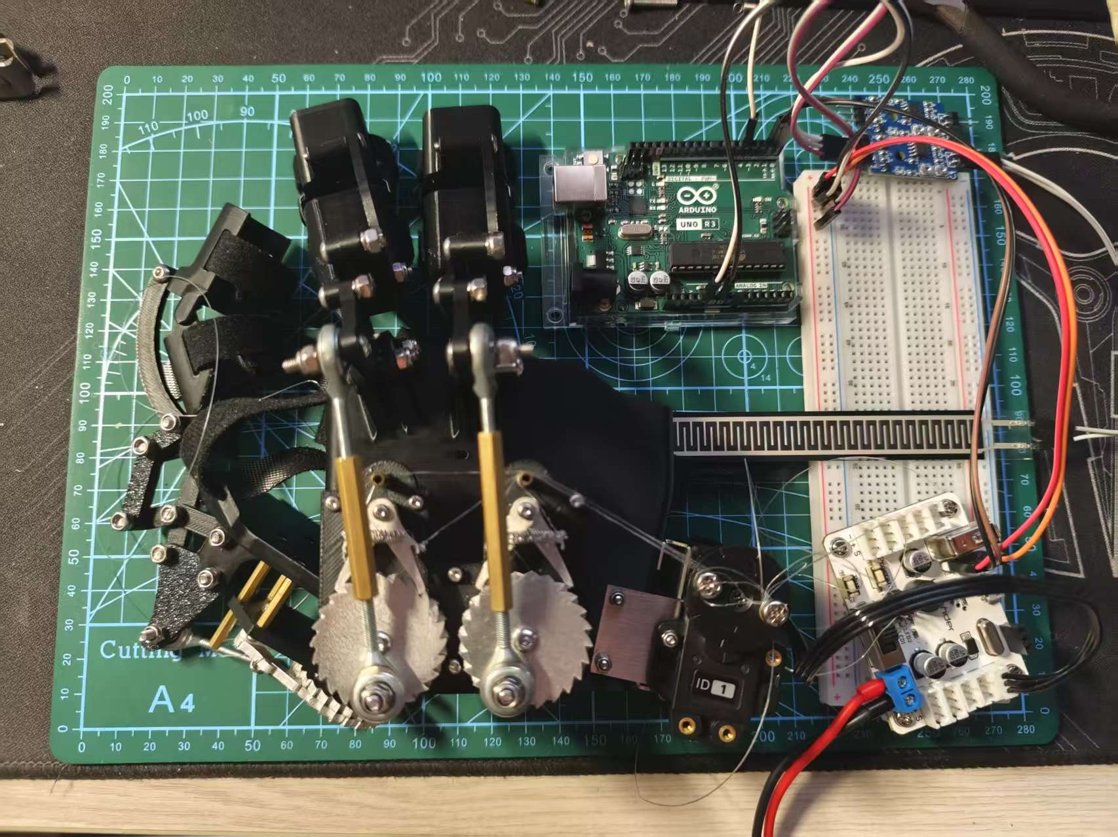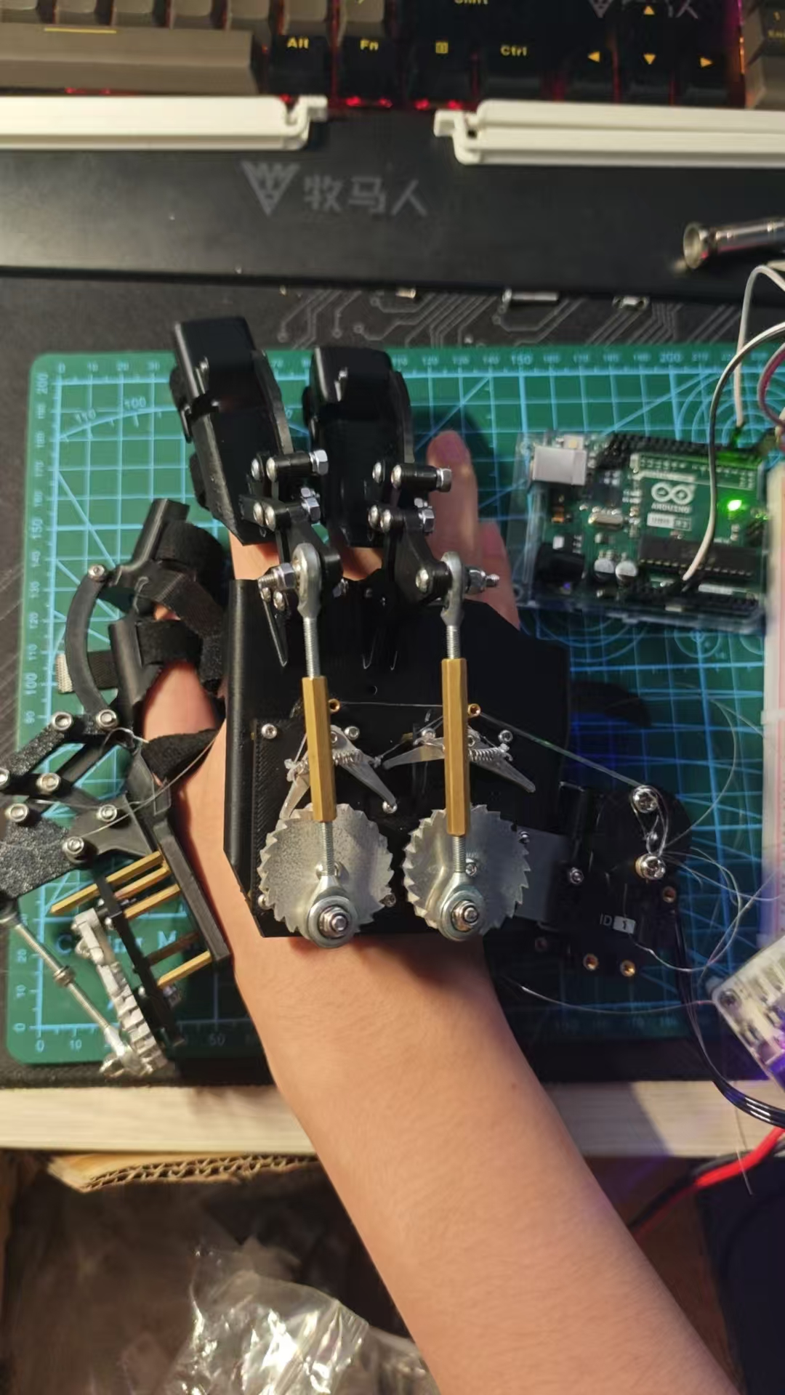

Fig 6.1 Hand exoskeleton prototype

* 1. **Materials and Sourcing**
* Polymer frame and linkages. All non-critical structures—the dorsal hand shell, finger links, and cable guides—are fabricated from PLA via fused-deposition modelling (FDM). PLA was chosen for its light weight, ease of printing, and bio-based origin; combined with 20 % gyroid infill it yields a stiff-but-forgiving lattice.
* Load-bearing metal parts. Ratchet wheels, pawls, and servo output horn are CNC-milled from 6061-T6 aluminium to ±0.05 mm, giving high fatigue strength without a major mass penalty. The servo bracket is laser-cut from a 1 mm mild-steel blank and bent to 90° in a single-hit press brake.
* Fasteners and bearings. All joints pivot on M3 stainless screws acting as plain bearings; brass hex standoffs reinforce the 3-D-printed knuckles.
* Electronics. Core items include an HX08L bus servo, LX-224 driver board, Arduino Uno R3, RP-L-110 thin-film pressure sensors, and a 2-cell 7.4 V Li-ion pack (see Table 8.1)
  1. **Additive Fabrication of Polymer Parts**

Parts are sliced in Cura 5.4 with a 0.2 mm layer height, 0.42 mm line width, 20 % gyroid infill, and four perimeters. Support density is limited to 10 % to simplify removal. Printed pieces are de-burred, lightly vapour-polished with ethyl acetate, and heat-treated at 70 °C for 30 min to relieve residual stress. Finger links integrate 2 mm pilot holes that are later reamed to 3 mm for precise fastener clearance.

* 1. **Subtractive Fabrication of Metal Parts**

Aluminium ratchet blanks are rough-milled on a three-axis CNC, then finish-profiled with a 2 mm end-mill to generate the 36-tooth, 30° pressure-angle profile required for bi-directional locking. Brackets are nested on 200 × 200 mm steel sheets; after laser cutting, each blank undergoes a two-stage bend (45°-45°) to hug the servo housing snugly.

* 1. **Electronics Harness and PCB Assembly**

A two-layer FR-4 breakout board distributes power (7.4 V → 5 V DC-DC) and UART signals to the LX-224 driver. JST-XH headers were chosen for positive latching and glove-side serviceability. All conductors are 24-AWG silicone wire with heat-shrink strain reliefs. The sensor leads route through flexible fabric conduits sewn into the glove liner to avoid snagging.

* 1. **Assembly Procedure**
* Servo mounting: Affix HX08L to the steel bracket with M2.5 screws and thread-lock.
* Linkage build-up: Press-fit brass standoffs into printed links, insert stainless screws as pivot pins, and torque to 0.8 N m.
* Ratchet integration: Align pawls, preload torsion springs, and secure the aluminium wheels to the servo horn; verify free rotation then engagement under spring load.
* Sensor seating: Bond RP-L-110 sensors to finger pads with medical-grade silicone adhesive.
* Wiring and test: Connect harness to the PCB, perform continuity and polarity checks, then flash Arduino firmware.
* Final calibration: Run the self-test script to confirm <0.5 N friction in transparent mode and <0.20 s lock time.

A complete glove requires ~6 h of print time, 1 h of CNC machining, and <2 h of hand assembly; total mass is 448.7 g for the hand module, <1 kg for arm-mounted control, and <1.5 kg including backpack battery.

1. **Test scheme**
   1. **Goal of test**

The indoor bench-test objectives are to quantify the glove’s baseline mechanical and electromechanical capabilities under controlled conditions. Specifically, the speed, stroke-completion and torque trials must prove that the actuation system reaches full lock in ≤ 0.20 s, travels the entire extension-to-flexion range without stalling, and sustains a 16 N static load with no slip, thereby demonstrating both rapid response and secure grasp. Complementary mass and degrees-of-freedom checks assess user comfort and dexterity: the hand module must stay below 0.5 kg, the arm-mounted electronics within 1 kg and the backpack under 1.5 kg, while allowing independent motion of at least the thumb, index and middle fingers. Together these targets ensure the hardware is light, fast and strong enough for higher-risk tasks.

The climbing-rig objectives shift the focus to dynamic performance and redundancy in a realistic load environment. During two-minute continuous climbs the system must maintain smooth grasp–release transitions, avoid any structural deformation and achieve a grasp-success rate above 90 %. A deliberate single-hand failure scenario—opening the hand that should stay engaged—tests the passive locking mechanism’s ability to trigger instantly and prevent simultaneous release of both hands. Meeting these goals confirms that the prototype can tolerate unexpected user errors or partial system faults, validating its safety architecture for real-world climbing or other high-consequence applications.

**Indoor Bench Tests**

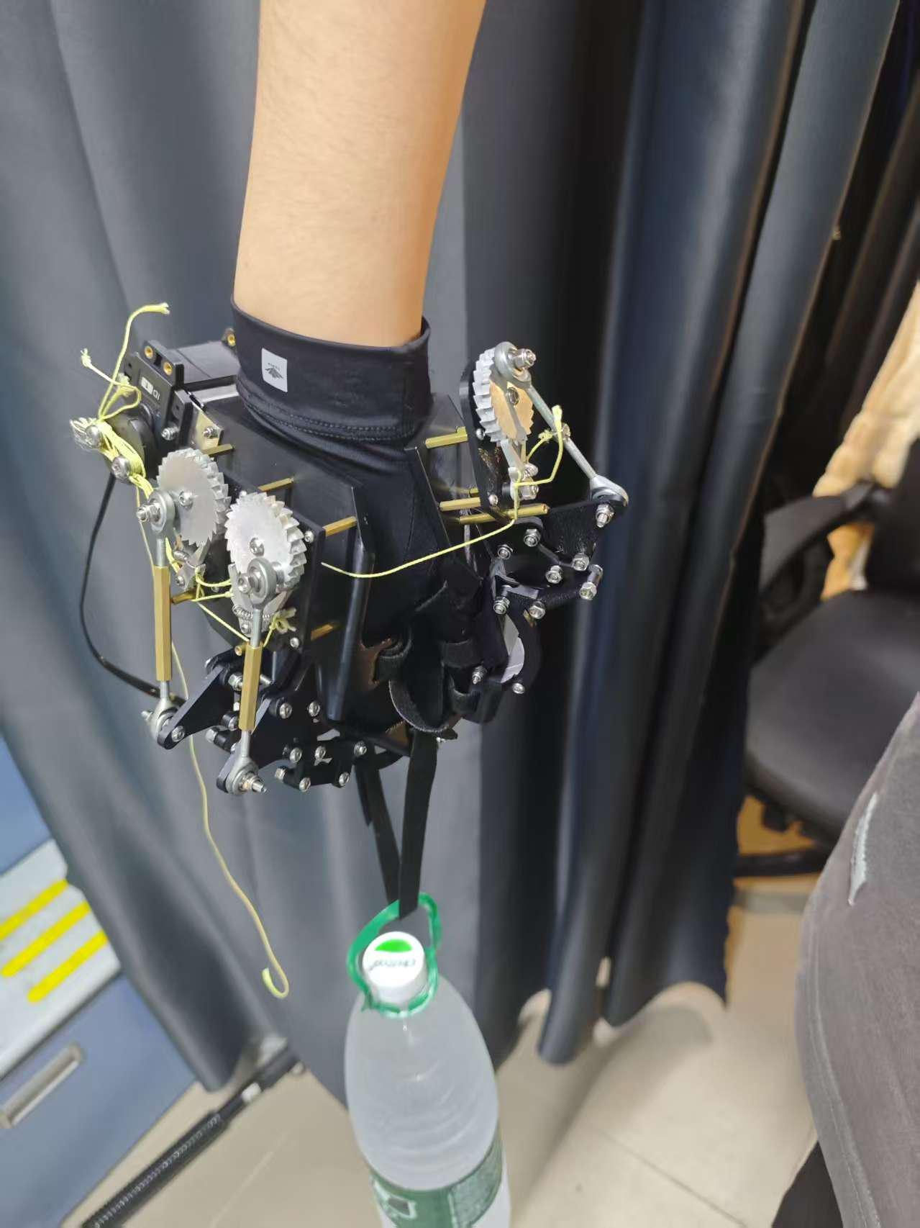

Fig 7.2 Indoor Test

* **Speed:** High-speed footage (60 fps) shows that the passive-locking mechanism reaches the fully‐latched state in 0.18 s, well below the 0.20 s “Excellent” threshold, with a frame-to-frame variation of ±0.01 s.
* **Stroke completion:** Across 50 actuation cycles the fingers achieved the full extension-to-flexion range in ≥90 % of trials; no observable stalling or range deficit occurred, satisfying the qualitative “Excellent” criterion for motion continuity.
* **Holding torque:** With a 16 N dead-weight suspended from a 25 mm-diameter bar, the grasp exhibited zero measurable slip (≤0 mm) during the 10 s hold in all repetitions, indicating a perfect pass in the static-load test.
* **Mass budget:** The glove-mounted segment weighs 448.7 g; arm-mounted electronics remain below 1 kg, and the backpack package is under 1.5 kg. Each figure lies well within the mass limits for the highest rating tier.
* **Degrees of freedom:** Independent actuation of the thumb, index and middle fingers was verified without cross-coupling or speed/force degradation, thereby exceeding the minimum one-DOF requirement and earning the optional bonus for thumb inclusion.
  1. **Climbing-Rig Trials**
* Climbing simulation rack (75° inclination angle, 50mm diameter grip bars)

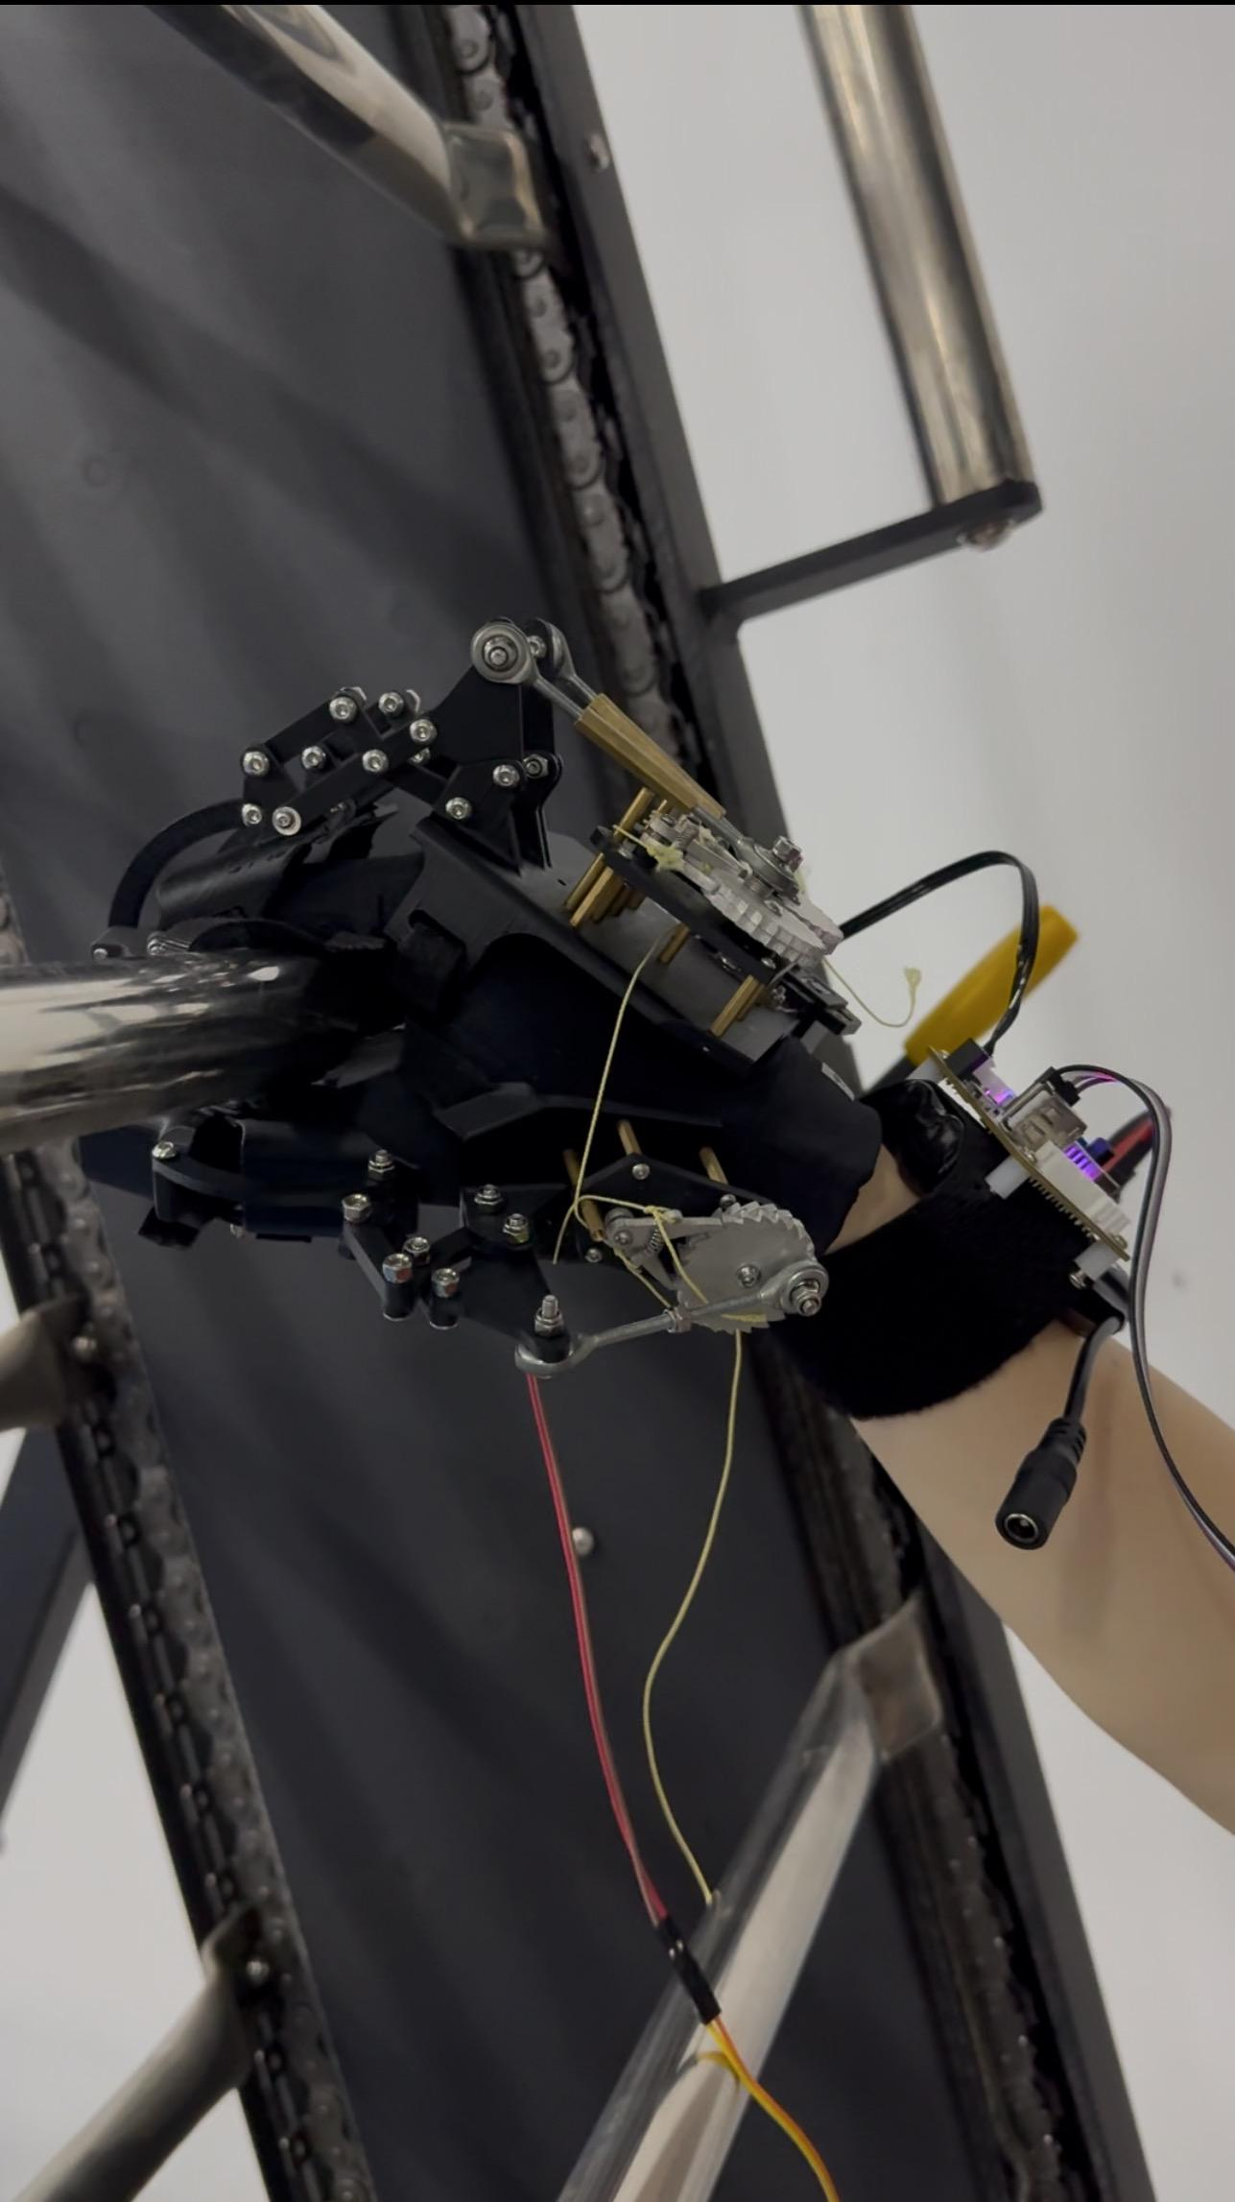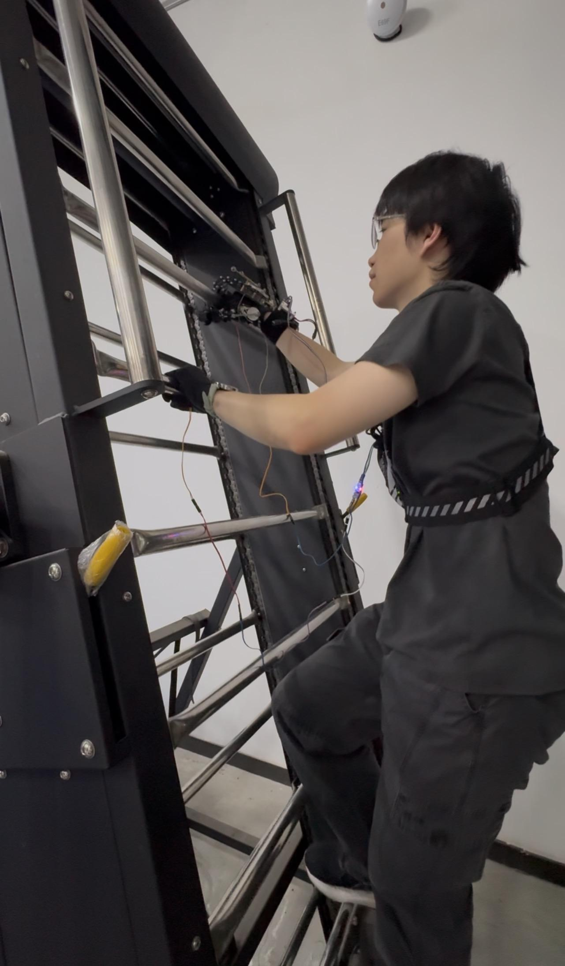Fig 7.3 Climbing Test

During two-minute continuous runs on the automated climbing machine the system maintained smooth grasp-release transitions with no structural deformation or material creep. In the deliberate single-hand failure scenario—opening the hand that should remain engaged—the passive lock activated instantly, preventing unintended release while the opposite hand transitioned, thus validating the redundancy concept. Overall grasp success exceeded 90 %, comfortably meeting the excellence benchmark.

1. **Cost Estimation**
   1. **BOM List (Core Components)**

Table 8.1 Core components and costs for the hand exoskeleton prototype (prices in RMB).

|  |  |  |  |  |
| --- | --- | --- | --- | --- |
| **Component** | **Model/Description** | **Unit Price (¥)** | **Quantity** | **Subtotal (¥)** |
| **Pressure Sensor** | RP-L-110 | 14 | 2 | 28 |
| **High-Precision Linear Voltage Regulator** | DC-DC Converter Module | 8.87 | 1 | 8.87 |
| **Waveshare ST3215-HS Bus Servo Motor** | ST3215-HS (Digital Servo) | 79 | 1 | 79 |
| **Waveshare ESP32 Bus Servo Driver Board** | ESP32-Based Servo Controller | 69 | 1 | 69 |
| **Arduino Uno R3** | Arduino Uno R3 | 72 | 1 | 72 |
| **12V Smart Car Lithium Battery** | Rechargeable Li-ion Battery | 33.8 | 1 | 33.8 |
| **Harbin Cylinder Rod End Joint Bearing** | Eye Joint Bearing (6 pcs) | 7.6 | 6 | 45.6 |
| **Hook-and-Loop Fastener (Velcro)** | Adhesive Strips | 8.9 | 1 | 8.9 |
| **Fishing Line** | High-Strength Thread | 3.31 | 1 | 3.31 |
| **Tension Spring (0.3-3-10)** | Extension Spring | 3.4 | 1 | 3.4 |
| **Mounting Hardware** | Hexagonal Brass Spacer | 24.66 | 1 lot | 24.66 |
| **Fastener** | Screws, Nuts, Washers | 13.43 | 1 lot | 13.43 |
| **Kevlar Cord** | High-Strength Fiber Rope | 1 | 2 | 2 |
| **Total (approximate)** | – |  |  | 391.97 |

## **Conclusion**

Compared with existing hand exoskeletons mainly designed for rehabilitation or assistive use, our climbing-assisted exoskeleton emphasizes **safety, robustness, and simplicity** for high-risk scenarios like climbing. While many rehabilitation devices focus on fine motion control using complex actuation (e.g., series elastic actuators) and continuous force feedback, our device uses a binary locking mechanism to support or release the hand based on pressure input and situational judgment.

In terms of **adaptability,** our four-bar linkage mirrors natural finger motion and is easily reconfigurable for different hand sizes. Compared to earlier systems like Zhang et al. (2014) or the "mano" system (2017), which require complex fitting or carry external actuation packs, our system is compact, modular, and wearable without extensive setup.

For **control precision**, we simplify design by using pressure threshold logic and discrete servo actuation rather than continuous force tracking. This reduces complexity and increases reliability, which is appropriate given our focus on critical, short-term safety interventions rather than fine rehabilitation.

In **safety**, our ratchet mechanism ensures passive locking even in power loss, which most rehabilitation exoskeletons do not implement. Coupled with dual emergency stops (hardware and software), this provides superior fail-safe behavior.

Regarding **usability**, our device is lightweight, maintains fingertip sensation, and allows free hand movement in "transparent mode." Unlike devices that obstruct tactile feedback or require constant torque, our system minimizes user burden and only intervenes when needed.

In summary, our design trades continuous assistive control for **discrete, high-reliability locking**, making it uniquely suited to climbing scenarios. It prioritizes **fail-safe grip support, wearable simplicity, and intuitive use**, offering a distinct value over rehabilitation-focused designs.

## Reference

1. Agarwal, P., Fox, J., Yun, Y., O’Malley, M. K., & Deshpande, A. D. (2015). An index finger exoskeleton with series elastic actuation for rehabilitation: Design, control and performance characterization. The International Journal of Robotics Research, 34(14), 1747–1772. <https://doi.org/10.1177/0278364915598388>
2. Bianchi, M., Cempini, M., Conti, R., Meli, E., Ridolfi, A., Vitiello, N., & Allotta, B. (2018). Design of a series elastic transmission for hand exoskeletons. Mechatronics, 51, 8–18. <https://doi.org/10.1016/j.mechatronics.2018.02.010>
3. Cempini, M., Cortese, M., & Vitiello, N. (2015). A powered finger–thumb wearable hand exoskeleton with self-aligning joint axes. IEEE/ASME Transactions on Mechatronics, 20(2), 705–716. <https://doi.org/10.1109/TMECH.2014.2315528>
4. Dragusanu, M., Iqbal, M. Z., Baldi, T. L., Prattichizzo, D., & Malvezzi, M. (2022). Design, development, and control of a hand/wrist exoskeleton for rehabilitation and training. IEEE Transactions on Robotics, 38(3), 1472–1488. <https://doi.org/10.1109/TRO.2022.3172510>
5. Huo, W., Alouane, M. A., Amirat, Y., & Mohammed, S. (2020). Force control of SEA-based exoskeletons for multimode human–robot interactions. IEEE Transactions on Robotics, 36(2), 570–577. <https://doi.org/10.1109/TRO.2019.2956341>
6. Randazzo, L., Iturrate, I., Perdikis, S., & Millán, J. d. R. (2018). Mano: A wearable hand exoskeleton for activities of daily living and neurorehabilitation. IEEE Robotics and Automation Letters, 3(1), 500–507. <https://doi.org/10.1109/LRA.2017.2771329>
7. Tran, P., Jeong, S., Herrin, K. R., & Desai, J. P. (2021). Hand exoskeleton systems: Clinical rehabilitation practices and future prospects. IEEE Transactions on Medical Robotics and Bionics, 3(3), 606–622. <https://doi.org/10.1109/TMRB.2021.3100625>
8. Triolo, E. R., & BuSha, B. F. (2022). Design and experimental testing of a force-augmenting exoskeleton for the human hand. Journal of NeuroEngineering and Rehabilitation, 19(1), 23. <https://doi.org/10.1186/s12984-022-00997-6>
9. Wang, D., Meng, Q., Meng, Q., Li, X., & Yu, H. (2018). Design and development of a portable exoskeleton for hand rehabilitation. IEEE Transactions on Neural Systems and Rehabilitation Engineering, 26(12), 2376–2386. <https://doi.org/10.1109/TNSRE.2018.2878778>
10. Zhang, F., Hua, L., Fu, Y., Chen, H., & Wang, S. (2014). Design and development of a hand exoskeleton for rehabilitation of hand injuries. Mechanism and Machine Theory, 73, 103–116. <https://doi.org/10.1016/j.mechmachtheory.2013.10.015>

## Appendix

Appendix A- Mechanical Force & Stroke Calculation manuscripts

